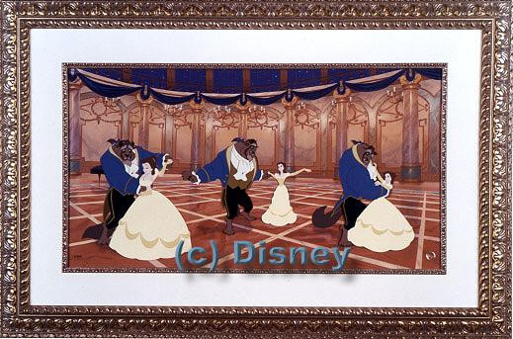

Carissa- My favorite band, group or DJ is Monica, Sisqo, and Destiny’s Child.

Kim- “ “ is LFO, DJ Buck, and DMX.

